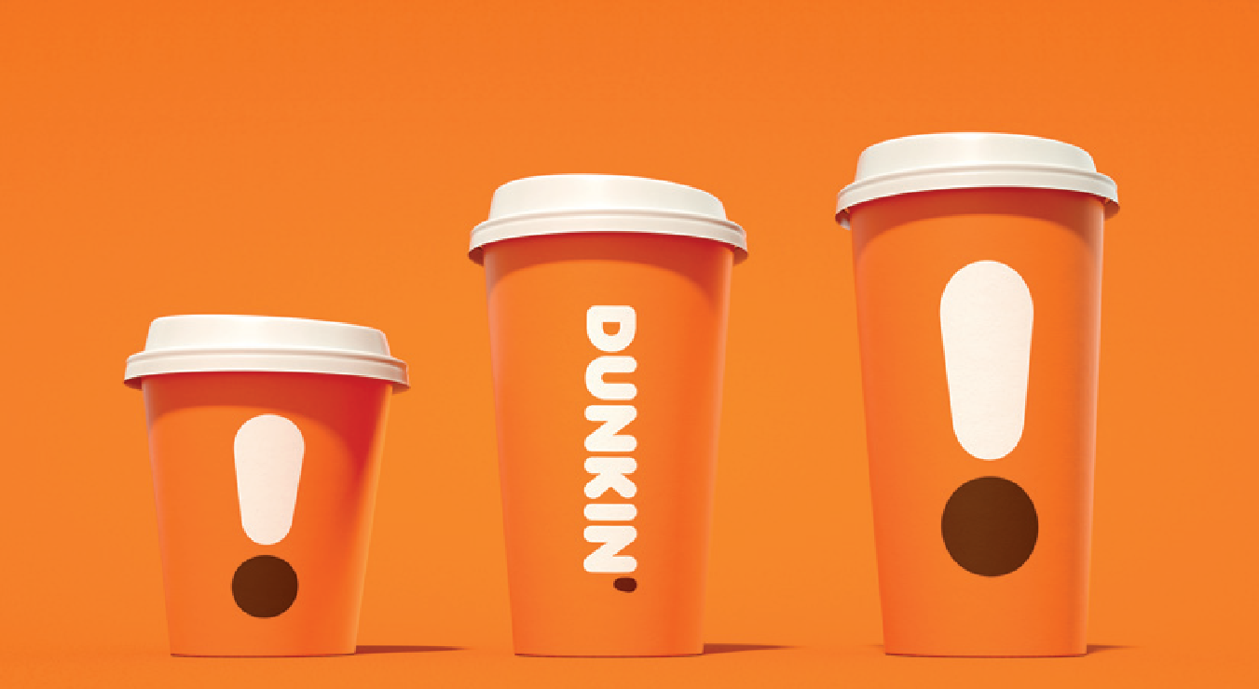

**MGF641: Financial Policies & Strategy**

**Team Project Report on Dunkin' Brands Group, Inc**

**Members - John Frucci, Saloni Shah, Niyati Rao, Shreya Chandak**

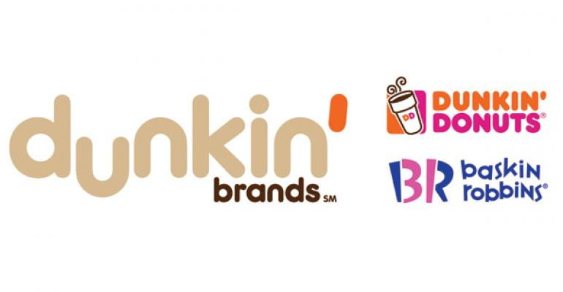

**COMPANY PROFILE:**

Dunkin' Brands Group, Inc., together with its subsidiaries, develops, franchises, and licenses quick service restaurants worldwide. The Company offers hot and cold coffee, baked goods, and ice-cream for drive-thru consumption. The company operates through five segments: Dunkin' U.S., Dunkin' International, Baskin-Robbins International, Baskin-Robbins U.S., and U.S. Advertising Funds. As of March 30, 2019, it had 12,900 Dunkin' Donuts restaurants and 8,000 Baskin-Robbins restaurants. The company franchises it's restaurants under the Dunkin' Donuts and Baskin-Robbins brands. Dunkin' Brands Group, Inc. is headquartered in Canton, Massachusetts. They believe that a 100% franchised business model offers strategic and financial benefits. Because they generally do not own or operate restaurants, they are able to focus on menu innovation, marketing, franchisee coaching and support, and other initiatives to drive the overall success of the brand. One of the major growth strategies of Dunkin is to open new domestic and international restaurants. If they fail to implement this strategy, their operating revenue is adversely affected. The international business is primarily conducted via joint ventures and country or territorial license arrangements with “master franchisees,” who operate and sub-franchise the brand within their licensed areas. The international franchise system is predominantly located across Asia and the Middle East. Major competitors are companies like Starbucks, McDonald’s, KFC, Subway, Panera and other food chains. Dunkin’ is a leading U.S. QSR concept, and is the QSR leader in donut and bagel categories for servings. Dunkin’ is also a national QSR leader for breakfast sandwich servings. Since the late 1980s, Dunkin’ has transformed itself into a coffee and beverage-based concept, and is a national QSR leader in servings in the hot regular/decaf/flavored coffee category and the iced regular/decaf/flavored coffee category, with sales of approximately 1.7 billion servings of total hot and iced coffee annually. National DCP LLC acts as an intermediate between farmers and Dunkin’s Brands to provide fresh produce in order for dunkin to manufacture.

**NEW GUIDELINES THAT IMPACT FINANCIAL STATEMENTS:**

In fiscal year 2018, Dunkin’s Brand adopted new guidance for revenue recognition related to contracts with customers and restated all financial statement amounts for fiscal years 2017 and 2016. Under the new guidance, revenue is recognized in accordance with a five-step revenue model, as follows: identifying the contract with the customer; identifying the performance obligations in the contract; determining the transaction price; allocating the transaction price to the performance obligations; and recognizing revenue when (or as) the entity satisfies a performance obligation.

The adoption of the new guidance changed the reporting of advertising fund contributions from franchisees and the related advertising fund expenditures, which were not previously included in the consolidated statements of operations. Additionally, advertising costs that have been incurred by the Company outside of the advertising funds were previously included within general and administrative expenses, net, but are now included within advertising expenses in the consolidated statements of operations.

New guidance requires a portion of sales of ice cream products to be allocated to royalty income as consideration for the use of the franchise license. As such, a portion of sales of ice cream and other products has been reclassified to franchise fees and royalty income in the consolidated statements of operations.

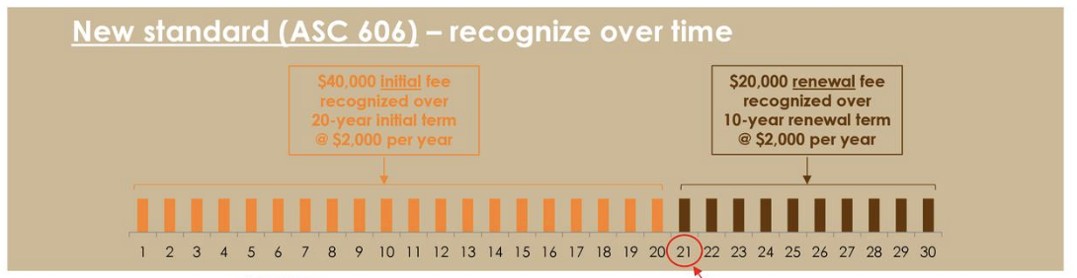

**ANALYSIS:**

**Operating margin ratio:**

Operating margin ratio is the return on sales which indicates how well a company can manage revenues against non-operating costs such as interest. The ideal operating margin ratio of the Quick Service Restaurant industry is around 35.78%. On computation, we could see that Dunkin’ Brands’ ratio for the year 2018 is 31.16%. The operating margin ratio of Dunkin’ has been on an upward trend when compared to the previous years. It has increased by 2.23% which is mainly due to the increase in franchisee income and advertising funds. Another factor which contributes to the increase in the margin is the sales of all the remaining company owned restaurants which decreased the operating expense by $13.6 million.

**P/E ratio:**

It refers to the ratio between the share price of the company and earning per share. The industry P/E ratio for 2018 is 21.61 whereas Dunkin’s P/E ratio is 23.20 in 2018. We can infer that the stock is overvalued because Dunkin’ is undergoing a strategic repositioning process with rebranding their brands and new innovations.

**Interest Coverage Ratio:**

Interest coverage ratio refers to how well a company can pay interest on the outstanding debt. Interest coverage ratio of Dunkin has reduced from 5.05 times in 2017 to 3.89 times in 2018. Dunkin’s interest expense increased by 20.2% million which was primarily driven by securitization of debt. This resulted in additional borrowings which in turn increases the company’s interest burden.

**Debt to EBITDA:**

This ratio refers to the company’s ability to pay off its incurred debt. A high ratio indicates that the company has an extremely heavy debt load. The ideal debt to EBITDA ratio is 6 whereas Dunkin’s ratio is 6.5. It has increased over the years as Dunkin’ has securitized debt and there have also been additional funds which have been borrowed.

**Return on Assets:**

It is an indicator of how well a company utilizes its assets by determining how profitable a company is relative to its total assets. It also takes into account the company’s debt. Dunkin’s return on asset was 6.65% in 2018 and 6.88% in 2017. Dunkin’ had incurred more capital expenditure in 2018. If they were efficiently utilizing the assets they had invested in, the ROA should have been more but the ROA has decreased despite the increase in capital expenditure.

**Working Capital:**

It is a measure of company’s liquidity, operational efficiency and short-term financial health. Dunkin’s working capital has decreased which indicates that its liquidity has decreased. Their working capital has decreased which means that they don’t have enough funds to fund their day-to-day expenses. Another inference that can be made is that they are stretching their credit period which means that they are not paying their creditors as often.

**Asset Turnover:**

This ratio measures how effectively the company uses its assets to generate sales. If a company has a high asset turnover ratio, it would mean that they are using the resources efficiently and generating more sales. Conversely, if a company has a low asset turnover ratio, it would mean that the company is not using its assets efficiently. Dunkin’s ratio for the year 2018 was 0.3575 times and was 0.3561 times in 2017. When the ratios of these two years are compared, it is evident that there is not much of a difference even though the company has a lot more capital expenditure in the year 2018. The reason behind negligible change in this ratio might also be due to their growth strategy. As their strategy is to open up new franchises every year, they require a lot of new equipment but it cannot be said that this investment would be a venture that efficiently uses its assets in its nascent stages.

**Analysis of Cash Flow Statements (CFS):**

1. Net income is increased by 15.22% when comparing year 2018 to 2017, this is mainly due to increase in the revenues by franchise fees
2. Accounts Payable has been increased by 4 times when comparing year 2018 with 2017 which means that the company has stretched the credit period
3. Dunkin sold the majority of its owned restaurants in the year 2016 and some of it in 2017 which is reflected in the proceeds from sale of company operated restaurants. After which the company has stopped investing in its owned restaurants
4. As per the CFS, Dunkin has made additions in the property and equipments by 1.46 times as reflected in the net cash from investing activities - this syncs with the company’s strategy of increasing the number of franchise stores overtime
5. In the year 2016, the company raised long term debt - which was utilised to pay off the previous debt balance. This was a refinancing strategy adopted by Dunkin.
6. Overall, the cash and cash equivalents show a negative balance - majorly due to buy back of shares in the year 2018.

**Trading History: Time for Optimal Growth**

1. Recently Dunkin Donuts has taken an initiative to have a **Simplified Menu.** For all locations, there has been a 10% reduction of required menu items. They also eliminated 23 other optional products.
2. Expanding its footprint and brand. They opened about 1000 new locations. Similar to Mcdonalds they are converting all their locations into NextGen stores.
3. Growth in stock due to **share repurchase**. By starting a $650 million accelerated share repurchase. One of the main factors in earnings growth.
4. New introduction of branded dunkin donuts consumer products at retail locations such as gas stations. In addition to their previous sellable items such as ice cream. The total portfolio of products sold has crossed $400 million in retail sales.
5. By focusing on convenience, they started new incentive programs that focus on customer loyalty. They are trying to focus on third party delivery systems to enhance the customer experience.
6. Commitment to invest a $100 million into the Dunkin Business. With about 65% of this towards equipment that would accelerate its beverage led strategy. The main focus of this strategy was to grow the cold brew and frozen categories.

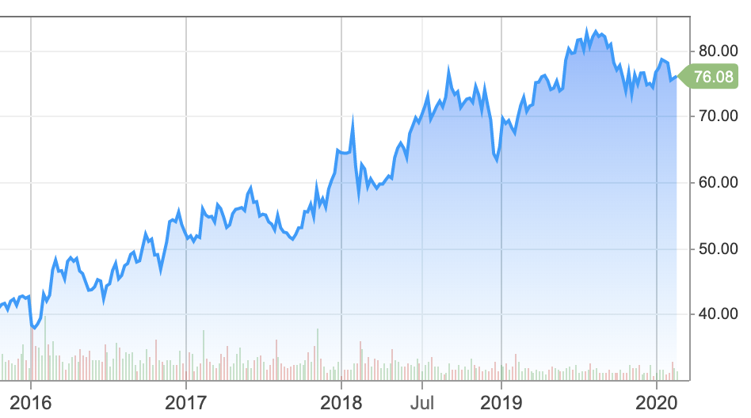

The above strategies were first executed in 2018. From the stock markets growth its very clear that these strategies helped grow the company.